**Full Stack Development with MERN**

**1. Introduction**

**Project Title: Book Store.**

**Team ID: NM2024TMID11488**

**Team Members:**

1. **Anamuddin Ahmad** - *Frontend Developer & Team Lead*: Responsible for leading the team and developing the user interface, focusing on creating reusable UI components, ensuring a smooth user experience and also Works on styling and layout design using Bootstrap and Material UI to enhance the visual appeal and usability of the application.
2. **Harsh Anand** - *Backend Developer*: Focuses on setting up server-side functionalities, implementing APIs, and managing data flow between the frontend and backend.
3. **Aman Ahmad** - *Database Manager & Documentation*: Manages database schema design, ensuring efficient data storage and retrieval for users, complaints, and messages .
4. **Kaif Ali** - Handles testing to ensure smooth functionality, along with documenting project development processes and user guidelines.

**2. Project Overview**

**Purpose:**

Introducing the Book-Store Application, a seamlessly crafted solution built with the robust MERN (MongoDB, Express.js, React, Node.js) Stack. Step into a digital space where a passion for books meets modern technology, transforming the way readers explore, discover, and immerse themselves in their literary adventures.

**Features:**

Enjoy the convenience of purchasing books online without sacrificing your reading preferences or the joy of browsing a traditional bookstore.

1. User Registration and Authentication: Enable users to securely create accounts, log in, and authenticate their identities to gain access to the bookstore platform.

2. Book Listings: Present a comprehensive catalog of available books, showcasing details such as title, author, genre, description, price, and availability.

3. Book Selection: Offer users a variety of filters to help them find their ideal books based on criteria like genre, author, ratings, and popularity.

4. Purchase Process: Allow users to easily add books to their cart, specify quantities, and complete transactions securely. Once the purchase is confirmed, an order is generated, and the inventory is automatically updated.

5. Order Confirmation: Provide users with an order confirmation page or notification that includes detailed information about their purchase, including book titles, total price, and order ID.

6. Order History: Give users the ability to view their past and current orders, track shipments, leave reviews on purchased books, and rate their overall shopping experience.

**3. Architecture**

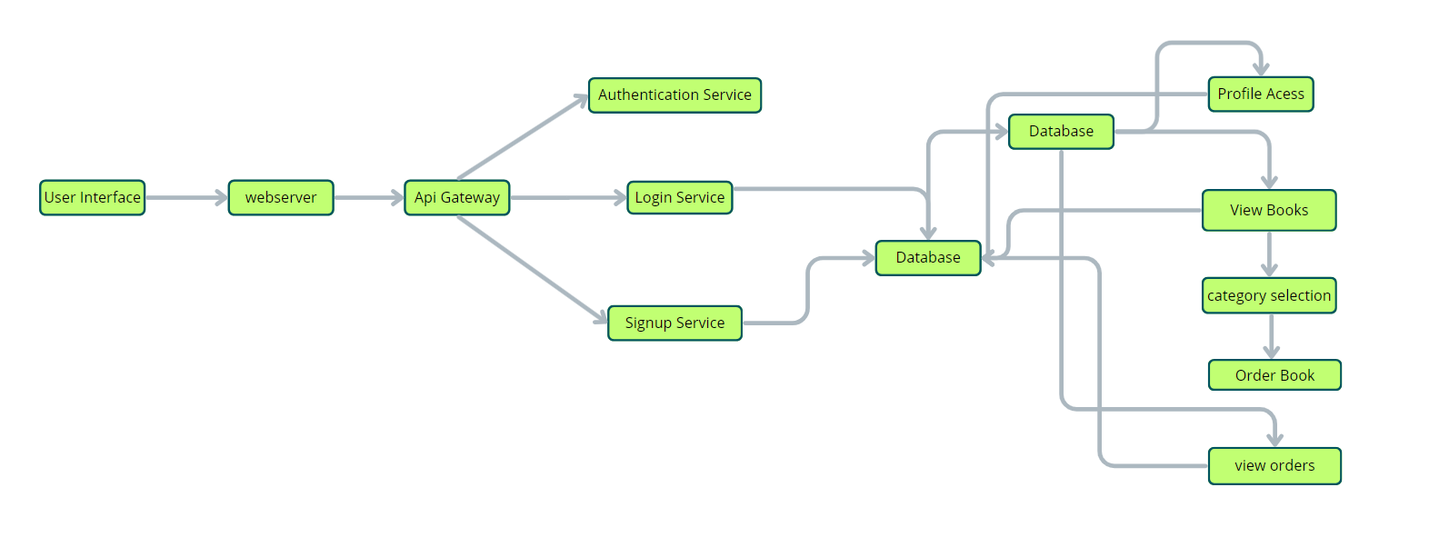

Frontend:

**The frontend is responsible for the user interface (UI) where customers can browse, select, and purchase books, as well as interact with various features of the bookstore platform.**

**1. HTML/CSS/JavaScript: Core technologies used to structure, design, and add interactive behavior to web pages, ensuring a seamless and engaging experience for users.**

**2. Frontend Frameworks/Libraries:**

**React.js : A popular JavaScript library used for building dynamic and responsive user interfaces. With its component-based architecture, React helps efficiently manage the dynamic elements of the bookstore, such as product listings, search filters, and user authentication flows.**

**3. CSS Framework :**

**Bootstrap : A widely used CSS framework that accelerates UI development with pre-built responsive design components. Perfect for ensuring the bookstore looks great across devices.**

**Tailwind CSS : A utility-first CSS framework, Tailwind allows custom designs with minimal custom CSS. This flexibility ensures a highly personalized look and feel for the bookstore, adapting to unique branding needs.**

**4. UI Libraries :**

**Material UI (for React) : A collection of pre-designed React components following Google's Material Design principles. Ideal for creating a polished, user-friendly interface for the bookstore, from product cards to shopping carts and user profiles.**

Backend:

**The backend is responsible for managing business logic, handling data flow, processing user requests, and interacting with the database to provide a smooth shopping experience for customers.**

**1. Backend Frameworks :**

**Node.js with Express : A powerful combination for building scalable server-side applications. Express, a minimal web framework for Node.js, handles routing, HTTP requests, and database connectivity, enabling smooth operations like order processing and inventory management for the bookstore.**

**2. Authentication/Authorization :**

**JWT (JSON Web Tokens) : A widely-used standard for securely transmitting information between the frontend and backend. JWT is used to authenticate users, allowing them to securely log in, make purchases, and access their order history and profile details.**

**3. REST :**

**RESTful APIs : REST APIs facilitate client-server communication. For the bookstore, RESTful APIs are used for operations such as fetching book listings (GET), adding books to the cart (POST), updating user profiles (PUT), and processing orders (DELETE).**

Database:

**1. MongoDB : The database of choice for the Bookstore Application, selected for its flexibility, scalability, and document-based structure. MongoDB is ideal for managing diverse data types, such as book details, user information, order history, and inventory levels. The database’s scalability ensures that the platform can handle a growing catalog of books and an increasing number of users without compromising performance.**

**- MongoDB’s document-based architecture enables efficient storage and retrieval of complex data sets, such as book categories, user preferences, and purchase histories. This ensures a fast and responsive experience for customers browsing books, placing orders, and viewing their past purchases.**

**- With MongoDB's high availability and quick data access, users can enjoy a seamless experience when exploring the bookstore, managing their carts, and completing their orders, while inventory and order data are efficiently updated in real-time.**

**4. Setup Instructions**

**Prerequisites for Developing a Full-Stack Bookstore Application using Node.js, Express.js, MongoDB, and React.js**

**To build a full-stack bookstore application with features like product browsing, shopping cart management, user authentication, and order processing, you'll need the following tools and technologies:**

**1. Node.js and npm :**

**Node.js : A powerful JavaScript runtime environment that enables server-side JavaScript execution. It's perfect for building scalable and high-performance network applications like our bookstore platform.**

**Installation : Download and install “Node.js” and “npm” (Node Package Manager) on your development machine. npm is essential for managing project dependencies.**

**2. Express.js :**

**Express.js : A lightweight, minimal framework for Node.js that simplifies API development and server-side logic. Express handles routing, HTTP requests, and middleware for our bookstore application.**

**Installation : To install Express, open your terminal and run:**

**bash**

**npm install express**

**3. MongoDB :**

**MongoDB : A flexible, scalable NoSQL database that stores data in a JSON-like format. MongoDB is ideal for storing large volumes of data such as user profiles, book listings, and orders in our bookstore.**

**Setup : Download and install MongoDB. You'll configure it to store and manage data like user accounts, books, shopping cart details, and order history.**

**Database Connectivity : Use “Mongoose”, an ODM (Object-Document Mapping) library, to simplify interactions with MongoDB. Mongoose allows for easy CRUD operations and schema management.**

**To install Mongoose:**

**bash**

**npm install mongoose**

**4. React.js :**

**React.js : A JavaScript library for building user interfaces. React allows you to create reusable and dynamic UI components, making it ideal for the interactive frontend of the bookstore application, including features like book search, browsing, and checkout.**

**Installation : Follow this guide to install “React.js” and set up the user-facing side of the bookstore (book browsing, cart management, and checkout process):**

**bash**

**npx create-react-app bookstore-frontend**

**5. HTML, CSS, and JavaScript :**

**HTML : The markup language used to structure the pages of the bookstore (e.g., product listings, user registration forms).**

**CSS : Used for styling the application, making it visually appealing and responsive across devices.**

**JavaScript : Provides interactivity and dynamic behavior, such as adding books to the cart and updating the user interface in real time.**

**6. Front-End Libraries :**

**Material UI : A React UI library that provides pre-designed components based on Google’s Material Design principles, ideal for creating a polished and modern UI for the bookstore.**

**Bootstrap : A popular CSS framework that helps in building responsive, mobile-first layouts. It can be used alongside React for easy layout and component management.**

**7. Version Control :**

**Git : A version control system that helps you track changes to your code and collaborate with others.**

**“GitHub” or “Bitbucket” : Platforms to host your code repository and collaborate with others. If you don’t have Git installed, follow the installation instructions [here](https://git-scm.com/book/en/v2/Getting-Started-Installing-Git).**

**8. Development Environment :**

**- Choose a code editor or IDE that suits your workflow. Common choices include:**

**- Visual Studio Code**

**- You can download “Visual Studio Code” (https://code.visualstudio.com/).**

**9. Setting Up the Project :**

**1. Clone the Repository:**

**Open your terminal and navigate to the directory where you want to store the bookstore application. Clone the repository from GitHub:**

**bash**

**git clone** [**https://github.com/yourusername/bookstore-app.git**](https://github.com/yourusername/bookstore-app.git)

**2. Install Dependencies:**

**- Navigate to the project directory:**

**bash**

**cd bookstore-app**

**-“ Install frontend dependencies” by navigating to the `frontend` folder:**

**bash**

**cd frontend**

**npm install**

**- “Install backend dependencies” by navigating to the `backend` folder:**

**bash**

**cd ../backend**

**npm install**

**3. Start the Development Server:**

**To start both the frontend and backend servers:**

**- Start the frontend server :**

**bash**

**npm start**

**This will start the React development server, and the bookstore UI will be accessible at [http://localhost:3000](http://localhost:3000).**

**- “Start the backend server”:**

**Go to the `backend` directory and start the server:**

**bash**

**npm start**

**The API (for managing books, orders, and users) will be available on a separate port, typically `http://localhost:5000`.**

**“Now You're Ready to Develop!”**

**With this setup, you can start developing and customizing your “Bookstore Application” by:**

**- Adding features such as user authentication, book search, cart management, and checkout.**

**- Customizing the UI using “Material UI” and “Bootstrap” for responsive design.**

**- Integrating the frontend and backend with RESTful APIs and MongoDB for data storage.**

**This setup will allow you to work locally and test your application as you go. Happy coding!**

**5. Folder Structure**

Frontend:

The 'frontend' directory of the bookstore application is structured into “components”, “pages”, “services”, and “assets” modularity and scalability:

Components : Reusable UI elements like book cards, search bars, and the shopping cart.

Page : Specific views such as the homepage, book detail page, cart, and checkout.

Services : Handle business logic and API communication (e.g., fetching books, managing user authentication, and processing orders).

Assets : Static files like images, icons, and fonts.

This organization ensures easy maintenance and scalability as the application grows. 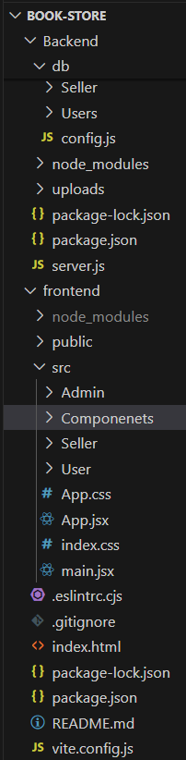

Backend:

The “backend” directory handles server-side logic, API routes, and database configurations for the bookstore:

API Routes : Manage user accounts, book listings, shopping cart, and order processing.

Database Configurations : Set up MongoDB connections and define schemas for users, books, orders, and cart data.

This structure ensures clear separation of concerns and maintainable code for the bookstore application.

.



**6. Running the Application**

To successfully launch and run the **Bookstore Application**, the frontend and backend need to be started separately, as they are developed independently. This guide outlines the steps to set up and run both the frontend and backend components, ensuring they connect seamlessly for full functionality.

1. Running the Frontend

The frontend of the Bookstore Application is built with React, handling the user interface and all client-side operations. This includes displaying product listings, managing the shopping cart, processing orders, and handling API requests to the backend for data retrieval and updates. To run the frontend, follow these steps:

1. Navigate to the Frontend Directory:

- Open your terminal or command prompt.

- Navigate to the directory where the frontend code is located. This should be the directory where you initialized the React app, often named `frontend`.

Example command:

bash

cd frontend

2. Install Dependencies:

Before starting the application, ensure that all dependencies are installed. Run the following command to install any missing packages specified in `package.json`:

```bash

npm install

```

Got it! Here's the same content without the asterisks and backticks:

---

3. Start the Frontend Server:

After installing dependencies, start the React development server with the following command:

npm start

- This command will launch the application on `http://localhost:3000` by default. You should see the landing page of the bookstore in your browser if everything is set up correctly.

- The frontend server supports live reloading, so any changes made to the code will automatically update in the browser.

4. Check Frontend Components:

- Ensure that key components, such as the homepage, product pages, and shopping cart page, are rendering correctly. Verify that the navigation system allows smooth access to different sections of the app, like product listings, user profile, and checkout.

5. Running the Backend

The backend of the Bookstore Application is powered by Express.js, handling server-side logic, data processing, and interactions with the MongoDB database. The backend provides APIs that the frontend can call to perform operations like retrieving books, managing user accounts, processing orders, and handling payment. To run the backend, proceed as follows:

1. Navigate to the Backend Directory:

- Open a new terminal window or tab.

- Move to the directory where the backend code is located, typically named `backend`.

Example command:

cd backend

2. Install Backend Dependencies:

Similar to the frontend, the backend requires certain packages to function correctly. Use the following command to install all required dependencies listed in `package.json`:

npm install

3. Configure Environment Variables:

- Ensure that environment variables, such as the database URI and authentication keys, are correctly configured in a `.env` file within the backend directory. This file should define:

- `DB_URI`: Connection string for MongoDB.

- `JWT_SECRET`: Secret key for JSON Web Token (JWT) authentication.

- `PORT`: Port on which the backend server will run (if different from the default).

4. Start the Backend Server:

After all configurations are in place, start the backend server by running:

npm start

- This command will initiate the server on `http://localhost:8000` (or the specified port).

- The backend server will listen for API requests from the frontend and respond with data or process updates, depending on the request type.

5. Verify API Endpoints:

- Once the backend server is running, verify key API endpoints like `/api/books`, `/api/users`, and `/api/orders` to ensure they are accessible and working correctly. These endpoints are essential for functionalities like retrieving books, managing user accounts, and processing orders.

**Testing the Full Application**

With both the frontend and backend running, open the browser and navigate to `http://localhost:3000` to access the bookstore application. Test the following core functionalities:

-User Registration: Allow new users to register with the system using their personal details (e.g., email, shipping address, etc.).

- Login/Logout: Provide secure login functionality (e.g., using username/password or JWT authentication) to access user-specific features like the shopping cart and order history.

- Browse and Search Books : Ensure users can browse books by category, author, or title, and filter/search based on various criteria.

- Shopping Cart Management: Allow users to add and remove books from the cart, adjust quantities, and proceed to checkout.

- Order Placement: Enable users to review their cart and complete the purchase with payment processing (e.g., integrating a payment gateway like Stripe or PayPal).

- Admin Features: Ensure admin users can manage the book inventory, view and process orders, and handle customer inquiries or complaints.

This ensures that the bookstore application is fully functional, from user registration to order completion.

**API Documentation**

This API documentation provides the endpoints and usage details for the Bookstore Application. The system allows users to browse and purchase books, manage their shopping carts, view order details, and track their order status. The API is designed for integration with both web and mobile applications.

1. Register a New User

- Endpoint: `POST /users/register`

- Description: This endpoint allows users to create a new account on the bookstore platform.

- Request Body:

{

"username": "string",

"email": "string",

"password": "string",

"address": "string",

"phone": "string"

}

- Response:

- 201 Created: User registered successfully.

- 400 Bad Request: Invalid input data.

2. User Login

- Endpoint: `POST /users/login`

- Description: Allows a user to log into their account and retrieve a JWT token for authentication.

- Request Body:

{

"email": "string",

"password": "string"

}

- Response:

- 200 OK: Successful login with JWT token.

- 401 Unauthorized: Incorrect credentials.

3. View Book Details

- Endpoint: `GET /books/{book_id}`

- Description: Fetch the details of a specific book using its unique book ID.

- Request Parameters:

- book_id: The unique identifier of the book.

- Response:

- 200 OK: Book details (title, author, genre, price, description, etc.)

- 404 Not Found: Book not found.

4. List All Books

- Endpoint: `GET /books`

- Description: Retrieve a list of all available books. Supports pagination and filtering by genre, author, price range, and availability status.

- Query Parameters:

- genre: Filter books by genre (e.g., "Fiction", "Non-fiction").

- author: Filter books by a specific author.

- price_min: Minimum price filter.

- price_max: Maximum price filter.

- availability: Filter by availability (e.g., "In Stock", "Out of Stock").

- page: Page number for pagination (default is `1`).

- per_page: Number of books per page (default is `20`).

- Response:

- 200 OK: A paginated list of books.

5. Add Book to Cart

- Endpoint: `POST /cart`

- Description: Add a book to the user's shopping cart.

- Request Body:

{

"book_id": "string",

"quantity": "integer"

}

- Response:

- 201 Created: Book successfully added to the cart.

- 400 Bad Request: Invalid book ID or quantity.

6. View Cart

- Endpoint: `GET /cart`

- Description: Retrieve the user's shopping cart, showing all added books and their quantities.

- Response:

- 200 OK: The shopping cart with book details and quantities.

7. Update Cart Item

- Endpoint: `PATCH /cart/{cart_item_id}`

- Description: Update the quantity of a book in the user's cart.

- Request Parameters:

- cart_item_id: The unique identifier of the cart item.

- Request Body:

{

"quantity": "integer"

}

- Response:

- 200 OK: The cart item has been updated successfully.

- 404 Not Found: The cart item was not found.

8. Delete Item from Cart

- Endpoint: `DELETE /cart/{cart_item_id}`

- Description: Remove a book from the shopping cart.

- Request Parameters:

- cart_item_id: The unique identifier of the cart item.

- Response:

- 200 OK: The cart item has been removed successfully.

- 404 Not Found: The cart item was not found.

9. Place Order

- Endpoint: `POST /orders`

- Description: Submit the user's cart and place an order.

- Request Body:

{

"cart_items": [

{

"book_id": "string",

"quantity": "integer"

}

],

"shipping_address": "string",

"payment_method": "string"

}

- Response:

- 201 Created: Order placed successfully with an order ID.

- 400 Bad Request: Invalid data or empty cart.

10. View Order Details

- Endpoint: `GET /orders/{order_id}`

- Description: Fetch the details of a specific order using the order ID.

- Request Parameters:

- order_id: The unique identifier of the order.

- Response:

- 200 OK: Order details (items, shipping address, payment status, etc.)

- 404 Not Found: Order not found.

11. List All Orders

- Endpoint: `GET /orders`

- Description: Retrieve a list of all orders for the logged-in user. Supports pagination and filtering by order status (e.g., "Pending", "Shipped", "Delivered").

- Query Parameters:

- status: Filter orders by status (e.g., "Pending", "Shipped", "Delivered").

- page: Page number for pagination (default is `1`).

- per_page: Number of orders per page (default is `20`).

- Response:

- 200 OK: A paginated list of orders.

This API documentation outlines the core features of the Bookstore Application, including user registration, browsing books, shopping cart management, order placement, and order management. The API is designed to be flexible and can be integrated with both web and mobile applications.

**8. Authentication**

Authentication is crucial in the Bookstore Application to ensure that only authorized users can perform specific actions, such as browsing books, adding items to the cart, making purchases, or managing the bookstore's inventory. To achieve secure and stateless authentication, we use **JSON Web Tokens (JWT)**. JWT allows secure transmission of user data and ensures that user sessions are managed without storing session data on the server.

User Registration :

- A new user registers on the bookstore platform by providing necessary details such as email, password, and role (e.g., “customer”, “admin”).

- The password is securely hashed using an algorithm like “bcrypt” before being stored in the database to protect user privacy.

- Upon successful registration, the system returns a success message, and the user can log in to access their account.

User Login :

- The user logs in by submitting their credentials (email and password).

- The server verifies the credentials by checking the hashed password in the database.

- If the credentials are valid, the server generates a JWT token, signing it with a secret key. The token contains claims about the user, such as:

- `user_id`: The unique identifier for the user.

- `role`: The user's role (e.g., customer, admin).

- `exp`: The expiration time of the token to ensure it’s only valid for a set period.

- The token is then returned to the client and used for subsequent requests to authenticate the user.

Storing JWT on the Frontend :

To keep the JWT secure, the client (browser) stores it in one of the following ways:

- HTTP-only Cookies : The JWT is stored in cookies with the `HttpOnly` and `Secure` flags. This ensures that the token is inaccessible to client-side JavaScript and is only sent over HTTPS connections, preventing Cross-Site Scripting (XSS) attacks.

- Local Storage / Session Storage: JWT can also be stored in the browser's local storage or session storage. However, this method is less secure than cookies due to the potential for XSS attacks.

Making Authenticated Requests:

For all subsequent requests, the client includes the JWT in the “Authorization” header:

Authorization: Bearer <JWT>

This token is sent with each request made to access protected routes, such as:

- Viewing the list of books

- Managing the shopping cart

- Placing an order

- Admin actions like managing book inventory

The JWT ensures that only authorized users can perform these actions.

Token Validation and Role-Based Access Control:

When the server receives a request with the JWT, it performs the following steps:

1. Token Verification: The server verifies the JWT's signature to ensure its authenticity. It also checks the token's expiration time (`exp`) to ensure it hasn’t expired.

2. Decoding the Token: If the token is valid, the server decodes the JWT to extract user information (e.g., `user_id`, `role`).

3. Role-Based Access Control (RBAC): The server checks the user's role and authorizes actions accordingly. For example:

- Customers can:

- Browse books

- Add books to the cart

- View their order history and place new orders

- Admins have full access, including:

- Adding, updating, and deleting books in the inventory

- Managing customer orders and complaints

- Support Staff can assist with managing customer complaints and processing returns or exchanges.

Refreshing JWT:

- JWTs typically have an expiration time (e.g., 1 hour) to reduce the risk of unauthorized access in case a token is compromised.

- Refresh Tokens are used to obtain a new access token without requiring the user to log in again. The refresh token is securely stored and used to request a new JWT once the current token expires. This process improves the user experience by maintaining their session without frequent logins.

Logging Out:

- Since JWT authentication is stateless, logging out is as simple as removing the JWT from the client’s storage (either local storage or cookies). There is no need for the server to invalidate the session because the token’s validity is self-contained within the JWT.

Example Flow for a Bookstore User:

1. Registration: A new user registers with their email, password, and role (e.g., customer).

2. Login: The user logs in with their credentials, and the server issues a JWT that includes their user ID and role.

3. Storing JWT: The JWT is stored in an HTTP-only cookie on the frontend for secure usage.

4. Accessing Protected Routes: The user accesses protected routes, like browsing books or managing the cart, by sending the JWT in the `Authorization` header.

5. Role-Based Access: The server checks the user's role and grants access to appropriate resources (e.g., customers cannot manage inventory, while admins can).

6. Session Expiry: When the JWT expires, the user can use a refresh token to obtain a new JWT and continue their session.

7. Logout: The user logs out by deleting the JWT from the client’s storage.

This authentication flow ensures a secure, efficient, and user-friendly experience in the Bookstore Application, with role-based access control to manage permissions effectively.

**9. User Interface for Bookstore Application**

**Home Page / Dashboard**

- Introduction / Overview: Briefly describes the purpose of the bookstore platform, how users can browse books, manage their shopping cart, and place orders.

- Login / Register: Allows users to log in or create a new account. Registration is required for features like order placement, viewing order history, and managing a personal wishlist. Option for guest browsing may also be available for casual users.

- Navigation Bar: Provides links to different sections such as:

- Browse Books (with categories)

- My Cart

- Order History

- Profile

- Admin Dashboard (for admins)

**Book Browsing / Search**

- Search Bar: Users can search for books by title, author, genre, or keyword.

- Filters and Categories: The ability to filter books by genre (e.g., Fiction, Non-fiction, Mystery), price range, availability (in stock or out of stock), and rating.

- Book Listings: Display of books in a grid or list format, with titles, authors, prices, and cover images. Users can click on a book to view its details.

- Book Details: A page where users can view the detailed description, reviews, price, available quantity, and an option to add the book to their cart or wishlist.

**Shopping Cart**

- Cart Overview: Displays all items added to the cart, along with their quantities and prices.

- Update Cart: Users can modify the quantity of items in the cart, remove items, or proceed to checkout.

- Total Price: Shows the total cost of items in the cart, including taxes and shipping fees.

- Proceed to Checkout Button: Takes the user to the checkout page where they can review their order, enter shipping information, and select a payment method.

**Order Placement**

- Checkout Form: Users are required to enter their shipping details (e.g., name, address, phone number).

- Payment Integration: Integration with payment gateways (e.g., Stripe, PayPal) to complete the purchase securely.

- Order Confirmation: After successful payment, users receive an order confirmation, including an order ID, list of purchased items, and estimated delivery time.

**Order History / Tracking**

- Order Dashboard: After login, users can view a list of their previous orders, including the current status (e.g., Pending, Shipped, Delivered).

- Order Status: Clear labels indicating whether an order is being processed, shipped, or delivered.

- Order Details: Clicking on an order provides more details, including a history of actions (e.g., dispatched, out for delivery) and tracking information, if applicable.

- Update Notifications: Users can receive updates via email or within the app (e.g., "Your order has shipped", "Order delivered").

**Admin Dashboard**

- Book Inventory Management: Admins can view and manage the bookstore's inventory, including adding new books, updating book details (price, availability, etc.), or deleting old books.

- Order Management: A dashboard showing a summary of all orders, including filters for order status (e.g., Pending, Shipped, Delivered), and the ability to update order statuses.

- Statistics: Visualizations (e.g., graphs, tables) showing sales trends, most popular books, monthly revenue, etc.

- Pending Tasks: A list of orders that need attention or are awaiting action from the administrator, such as processing returns or handling customer inquiries.

**User Management**

- User Profile Management: Admins can view and manage user profiles, including resetting passwords, updating personal information, and blocking/unblocking users if necessary.

- Permissions & Roles: Admins can assign different levels of access to various users:

- Customers: Regular users who can browse, order, and track purchases.

- Support Staff: Can assist with processing orders, customer inquiries, and handling returns/exchanges.

- Admins: Have full access to manage books, view all orders, and handle user accounts.

This structure adapts the original complaint registration and management system to the needs of an online bookstore, emphasizing browsing, purchasing, and order management while providing a simple and efficient user interface for both customers and admins.

**10. Testing**

A comprehensive testing strategy is implemented for the Bookstore Application to ensure functionality, reliability, and an optimal user experience. This strategy involves various testing methodologies, targeting both backend and frontend components of the application.

**1. User Interface (UI) Testing for frontend**

- Form Validation: Test that the book purchase and account registration forms correctly validate inputs such as required fields, email addresses, phone numbers, and shipping details.

- Are all mandatory fields highlighted?

- Does it show proper error messages for invalid inputs?

- Responsive Design: Ensure the website is responsive across different devices (desktop, tablet, mobile).

- Does the layout adjust properly on various screen sizes?

- Are buttons and text legible on all devices?

- Usability: Ensure the system is easy to use and navigate.

- Is the browsing and purchasing process intuitive?

- Can users easily find books, add items to the cart, and complete their orders?

**2. API Testing for backend**

- API Functionality: If your system uses APIs to handle book listings, orders, or payments, verify that the APIs are functioning correctly.

- Are books correctly listed and retrieved from the backend?

- Are order details and payment processing handled correctly by the API?

- End-to-End API Validation: Test API responses for valid inputs (e.g., successful book searches, valid order placement), invalid inputs, and edge cases.

- Does the API return appropriate status codes (e.g., 200 for success, 400 for bad requests, 500 for server errors)?

- Authentication & Authorization: If users need to be authenticated to make purchases or manage orders, ensure APIs correctly enforce security.

- Does the system block unauthorized requests from non-logged-in users trying to place orders?

- Are user credentials securely validated when accessing personal or payment information?

**3. End-to-End Testing**

- Order Workflow Test: Test the complete lifecycle from product browsing to order placement and delivery.

- A user browses books → Adds books to the cart → Proceeds to checkout → Payment is processed → Order confirmation is displayed → User is notified when the order ships or is delivered.

- Notification Testing: Verify that notifications (email/SMS) are sent when an order is placed, updated, or shipped.

- Is the user notified via email upon order placement?

- Are users informed when their order status changes (e.g., "Shipped," "Out for Delivery," "Delivered")?

**4. Regression Testing**

- Ensure that new changes (e.g., bug fixes, updates to book listings or payment systems) do not break existing features in the system. - Verify that previously placed orders, user profiles, and shopping cart data are still accessible and functional after updates.

**11. Screenshots or Demo :**

* Landing page

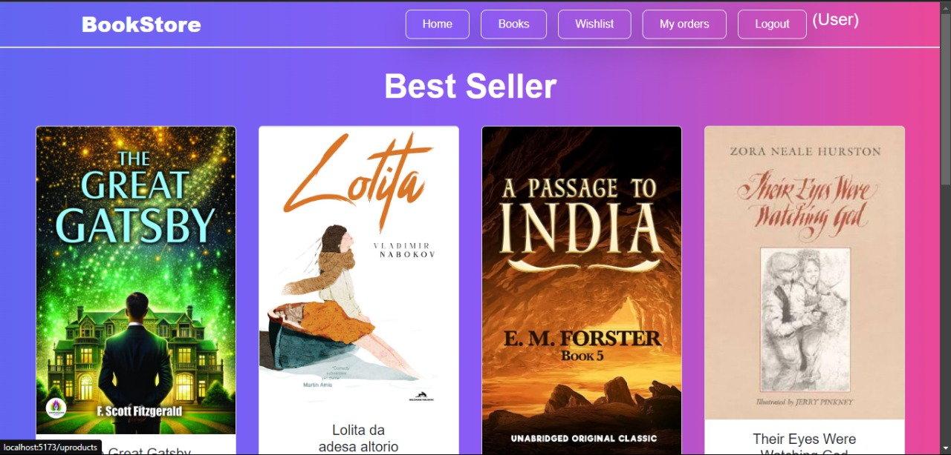

* Login Page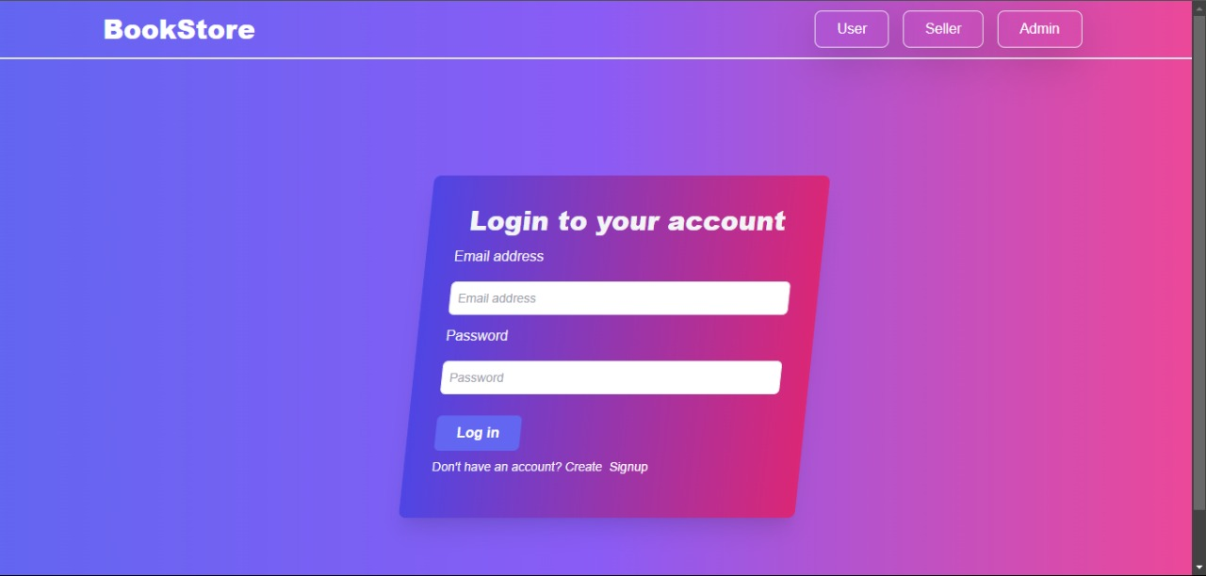
* Sign up Page

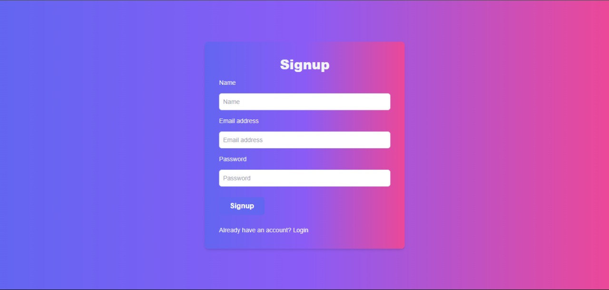

* · Admin Dashboard

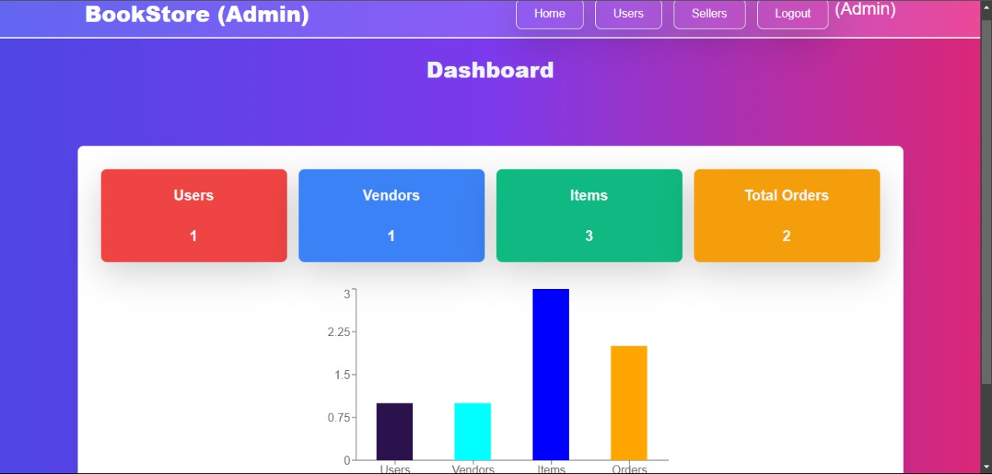

* · Agent Dashboard

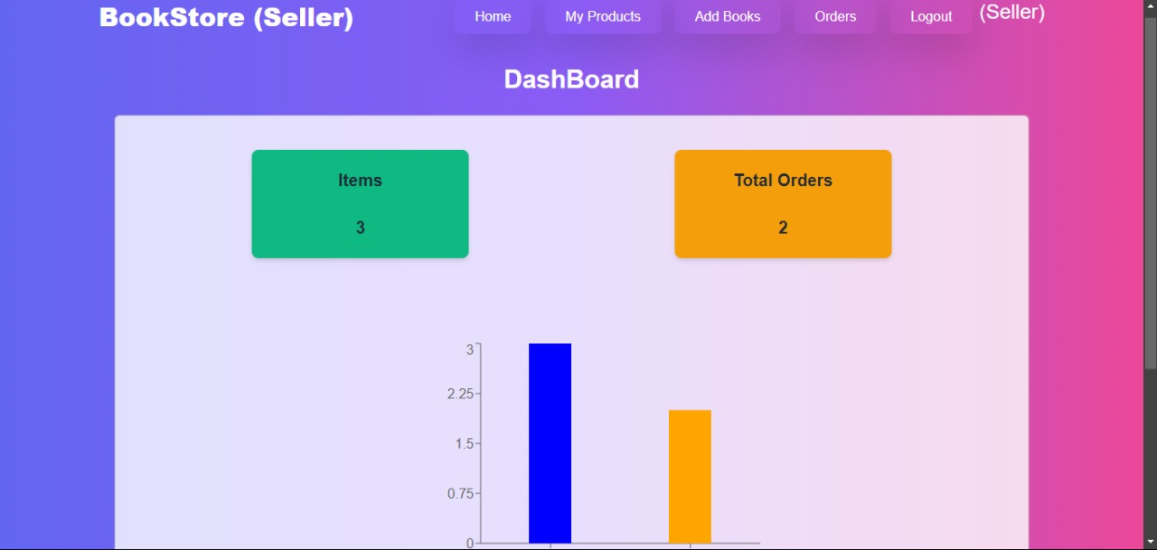

Before starting to work on this project, let’s see the demo.

**Project demo:**  <https://drive.google.com/file/d/1z-uzWmijSqjmQ9fd9rpBHlN0Bvq_y1kw/view?usp=drivesdk>

**Use the code** in: <https://github.com/AnamuddinAhmad/Nan-Mudalvan-Project.git> or follow the videos below for better understanding.

**12. Known Issues in Bookstore Online Complaint Registration and Management System**

When developing and implementing an Online Complaint Registration and Management System for a bookstore, several well-known issues and challenges often arise. These issues can be technical, functional, or user-related, and must be addressed to ensure an efficient, user-friendly system that improves customer satisfaction.

1. Complaint Categorization and Prioritization

- Issue: Categorizing complaints related to books (e.g., damaged items, incorrect titles, wrong quantity, delivery issues, etc.) and prioritizing them (e.g., urgent vs. low priority) can be difficult, especially without a clear framework or intelligent categorization algorithms.

- Solution: Implement machine learning or rule-based systems to automatically categorize complaints based on keywords (e.g., "damaged book," "wrong order," "missing page") or predefined criteria. Use a priority system for complaints based on factors such as urgency or impact (e.g., shipping delay vs. incorrect book delivery).

2. System Performance and Scalability

- Issue: A high volume of complaints, especially during peak shopping seasons (e.g., holiday sales or book release events), can overwhelm the system. Poor performance could lead to slow response times, failure to log complaints, or even system crashes.

- Solution: Ensure the system is scalable by integrating load balancing, optimizing database queries, and implementing cloud infrastructure capable of handling increased traffic during busy periods. This ensures that the system remains responsive even under high load.

3. User Experience and Interface Design

- Issue: A complicated or unintuitive interface can frustrate customers, preventing them from properly submitting complaints or tracking their resolutions. This is particularly important for customers trying to return damaged or incorrect books.

- Solution: Conduct usability testing and design an intuitive, easy-to-use interface. Ensure that the system is responsive and works seamlessly across devices (e.g., mobile, tablet, desktop). Allow users to quickly navigate to sections for returns, refunds, or exchanges with minimal clicks.

4. Complaint Resolution Tracking

- Issue: Tracking the status of complaints, such as whether a refund for a damaged book has been processed or if a replacement order has been shipped, can become cumbersome if the system doesn’t have clear status indicators or an intuitive interface.

- Solution: Implement a status tracking system that includes stages like "Received," "In Progress," "Resolved," and "Closed," along with automatic email or SMS notifications to customers about the progress of their complaints (e.g., "Your replacement book is on the way!").

5. Feedback Collection and Continuous Improvement

- Issue: The system may not collect enough user feedback about the complaint resolution process, making it difficult to improve the system and address common customer pain points (e.g., delays in delivery, damaged packaging).

- Solution: Include an option for customers to rate the resolution process (e.g., through a star rating system) and provide suggestions. Use this feedback to continuously improve the system and resolve recurring issues, such as poor packaging or shipping delays.

6. Difficult Navigation and Issue Tracking

- For Users: Without a search bar, customers may struggle to find specific complaints or track the status of their ongoing issues (e.g., complaints about missing book pages or incorrect editions). If the system allows users to view past complaints, not having a search function would make it hard for them to find their case based on keywords (e.g., "damaged book" or "order not received").

- For Admins: Administrators or support staff need an efficient way to find complaints based on various parameters (e.g., complaint ID, user name, book title, order number, priority). Without a search feature, admins may have to sift through a long list of complaints manually, which is time-consuming and error-prone.

7. Reduced User Experience

- Frustration for Users: Customers submitting complaints may later want to check the status of their complaint (e.g., is their refund processed, or is their replacement book on the way?). Without a search function, they may become frustrated by having to manually navigate through multiple pages or lists to find their case. This could lead to dissatisfaction, especially if finding relevant information is difficult.

- Limited Access to Information: Without a search bar, customers may not be able to filter or sort complaints based on urgency, category (e.g., book damage, delivery issues, billing issues), or other attributes, which reduces the system's flexibility and makes it harder to navigate efficiently.

8. Limited Customization for Users

- Search Filters Are Crucial: Many complaint systems allow users to filter complaints by date, category (e.g., billing issues, damaged books, late deliveries), priority (e.g., urgent vs. low), or other factors. A search bar provides more flexibility by allowing users to search for complaints using specific terms (e.g., "missing pages" or "wrong author") or by complaint ID.

- No Easy Way to Narrow Down Results: Without a search bar, customers might have to scroll through hundreds or thousands of complaints manually to find their own, which can be overwhelming. This issue becomes particularly problematic when the bookstore deals with a large number of complaints during high-volume sales periods (e.g., Black Friday or new book launches).

Additional Considerations for Bookstore Systems:

- Book-Specific Issues: Ensure that complaints are accurately categorized based on book-related factors (e.g., "book damaged during shipping," "incorrect edition sent," or "book missing pages").

- Integration with Inventory: Complaints related to stock issues (e.g., out-of-stock books or delivery delays) should be integrated with the bookstore's inventory system to prevent repeated complaints about unavailable items.

By addressing these common issues, bookstores can build a more efficient and user-friendly complaint management system, leading to improved customer satisfaction and better overall management of complaints.

This version highlights the specific context of a bookstore and includes examples relevant to book sales and services, such as damaged books, incorrect deliveries, and customer feedback on the complaint process.

13. Here is the revised version of the “Future Enhancements” for an “Online Complaint Registration and Management System”, specifically tailored to a “bookstore context”, without using any special characters like commas, asterisks, hashes, or quotation marks.

Future Enhancements for Bookstore Online Complaint Registration and Management System

1. **AI-Powered Complaint Categorization and Prioritization :**

- AI Integration: Implement machine learning algorithms to automatically categorize and prioritize complaints based on urgency, sentiment, and topic. For example, complaints about damaged books or incorrect orders can be flagged as urgent while inquiries about book availability or minor issues can be given lower priority.

- Natural Language Processing (NLP): Use NLP to analyze complaint text and identify key issues such as recurring problems with specific book titles, packaging issues, or frequent delivery delays. This helps in proactively addressing common problems and spotting emerging trends.

2. **Real-Time Status Tracking and Notifications :**

- User Dashboard: Develop a real-time tracking system where customers can monitor the status of their complaints at any time. The dashboard could show complaint stages like under review, in progress, resolved, and closed. For example, if a complaint about a damaged book is being processed, users could see updates on the resolution status.

- Automated Notifications: Send real-time notifications to users via email, SMS, or app alerts to inform them about updates on their complaints such as your replacement book has been shipped or your refund has been processed.

3. **Mobile Application :**

- Mobile-Friendly App: Create a dedicated mobile app to allow users to easily submit complaints, track their issues, and interact with the support team. Users could upload photos of damaged books or issue-related documents directly from their mobile devices to speed up the resolution process.

- Geolocation Integration: For issues like missing books from a physical store, integrate GPS functionality to track user location. This would be useful for complaints about incorrect in-store availability or delivery problems.

4. **Self-Service Resolution and Knowledge Base :**

- FAQs and Self-Help Section: Build a knowledge base with FAQs to help users solve common issues independently, such as how to return a book, the process for refund requests, or troubleshooting order discrepancies. This can reduce the number of complaints submitted and improve overall customer satisfaction.

- Automated Chatbot Support: Integrate an AI-powered chatbot to assist users instantly. The bot could guide customers through the complaint submission process, answer common queries about order status, book availability, or return policies, and even help track the resolution of complaints.

5. **Multi-Language Support :**

- Language Preferences: Provide multi-language support to ensure customers from diverse linguistic backgrounds can submit complaints and interact with the system in their preferred language, especially useful for bookstores with international customers.

- Translation Tools: Integrate real-time translation for complaints received in non-native languages, ensuring that customer service teams can understand and resolve complaints quickly, regardless of the user's language.

6. **Feedback and Rating System :**

- Post-Resolution Feedback: After a complaint is resolved, allow customers to rate the quality of the resolution and the responsiveness of the service. Feedback can focus on the handling of issues such as book damage, incorrect orders, or delivery delays.

- Complaint Resolution Analytics: Use feedback data to generate reports on the effectiveness of complaint resolutions, identifying areas like shipping problems, packaging issues, or common inventory-related complaints that need further improvement.

7. **Integration with Other Bookstore Services :**

- Cross-System Integration: Integrate the complaint system with other key bookstore systems such as inventory management, order fulfillment, and shipping. For example, if a customer complains about a book being out of stock or delayed, the complaint system could link to real-time inventory data to provide accurate updates on product availability.

- Data Sharing: Allow complaint data (with user consent) to be shared with relevant departments such as shipping, returns, or customer service to expedite resolution, especially for issues like delayed deliveries or wrong shipments.

8. **Voice and Image Recognition :**

- Voice Input: Allow customers to submit complaints using voice recognition (speech-to-text), which is especially useful for users with accessibility needs or for those who want to quickly report a problem while on the go. For instance, a customer could quickly report a damaged book by speaking into their device.

- Image and Video Uploads: Enable customers to upload photos or videos showing the issue, such as a damaged book, incorrect edition, or missing pages. Visual evidence can help resolve complaints faster, as it provides clear documentation of the problem.

9. **Advanced Security Features :**

- Two-Factor Authentication (2FA): To secure customer accounts and personal information, implement two-factor authentication when customers log into the complaint system. This ensures that only authorized users can access their complaint history or personal order information.

- Data Encryption: Ensure all customer and complaint-related data is encrypted both in transit and at rest, protecting sensitive information such as credit card details or personal addresses from unauthorized access.

10. **User Customization and Personalization :**

- Personalized Dashboards: Allow users to customize their dashboards to prioritize the complaints they care most about, such as tracking the status of a refund for a damaged book or a missing shipment. Users could set up alerts to notify them about updates on their specific complaints.

- Complaint History: Enable users to view a complete history of their complaints, including the status of each one, resolutions provided, and feedback received. This helps customers track their interactions and understand how issues were handled in the past.

11. **Integration with Social Media Platforms :**

- Social Media Complaints Handling: Enable users to submit complaints directly through social media platforms like Twitter, Facebook, or Instagram. Complaints raised on social media could be automatically logged into the system, categorized, and assigned to the relevant department for follow-up.

- Social Listening Tools: Implement tools to monitor mentions and complaints about the bookstore across social media in real-time. This helps to identify issues like widespread shipping delays or packaging problems that are affecting many customers, enabling quick responses to public concerns.

12. **Automated Compliance and SLA Management :**

- Service Level Agreements (SLA) Tracking: Automatically track and monitor SLAs to ensure that complaints are resolved within the specified timeframes. Alerts can be set to notify support teams if a complaint is nearing its deadline for resolution, ensuring timely responses for urgent issues.

- Audit Trails: Keep a detailed, transparent record of every action taken on each complaint, from submission to resolution. This provides accountability and allows users to see the full history of their complaint, improving trust and transparency.

13. **Enhanced Reporting for Administrators :**

- Role-Based Access: Implement role-based access for different user types such as customers, administrators, and support staff to control data access and ensure that sensitive information, like payment details, is only available to authorized personnel.

- Performance Metrics: Provide administrators with detailed reports on metrics such as average response time, resolution time, and complaint handling efficiency. These reports can help identify areas for improvement, such as slow response times for damaged book complaints or frequent order mix-ups.

These future enhancements can make the “bookstore complaint management system” more efficient, user-friendly, and customer-centric, leading to better customer satisfaction and smoother operations in resolving issues such as damaged books, wrong orders, and delivery delays. By adopting these advancements, bookstores can address complaints more quickly, improve transparency, and continuously refine their services based on customer feedback.